Student’s name | …………………………………………………….…… | Grade | 5
Subject | Computer | Week No. | 11
Lesson Title | Shapes and Angles | Unit
Worksheet No. ( 11 )

Question A: Fill in the blanks with the words in the box below.

Swan | Cat | Fish



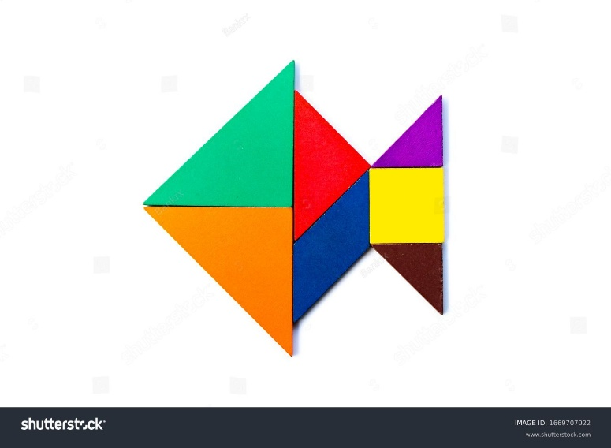
Good Luck

